

**Palestine Technical University – Kadoorie(PTUK)**

**College of Engineering and Technology**

**Department of Computer Systems Engineering**

Course Name :

Software Engineering

Project title :

***“Clinic On Call”***

***(COC)***

Submitted by :

|  |  |
| --- | --- |
| Students Name | Students ID |
| **Malak** |  |
| **Raghad Abu Zainih** | **202110697** |
| **Rama Bashar Anbosi** | **202111129** |

Supervisor: **Dr. Osama Hamed**

Spring 2024

**Table of contents :**

Abstract……………..……………..……………..……………..……………..……………..…..…………..3

**1. Introduction**

1.1 The Main Purpose…………………………………………………………………..………4

1.2 Document conventions………………………………………………………………..…6

1.3 Problem statement……………………………………………………………………....…6

1.4 Scope…………………………………………………………………………………………...…6

1.5 System objectives………………………………………………………………………...…7

1.6 Intended audience………………………………..……………………………………...…8

1.7 References…..……………………………………..……………………………….…..………9

**Abstract :**

**The *"COC"* system is an advanced solution designed to simplify and streamline the process of scheduling medical appointments, particularly in outpatient clinics. This project aims to provide a comprehensive platform where patients can easily book appointments with healthcare specialists through an online interface. The system facilitates patient-doctor interactions by offering features such as patient registration, identifying available doctors in each clinic, working hours, scheduling appointments, and appointment reminders (where a reminder will be sent to the patient through the application as the appointment approaches). So, the system prioritizes user convenience, efficiency, and accessibility.**

1. **Introduction**
   1. **The Main Purpose**

Our Palestinian people endure numerous pressures, challenges, and constraints in life compared to other countries, primarily due to the practices and violations by Israeli occupation authorities. These violations have affected all aspects of life and various vital sectors. For instance, the healthcare sector suffers from a lack of resources and medical equipment, compounded by financial constraints in providing these necessities. Additionally, the policy of siege, closure, and checkpoints hinders timely medical treatment and often poses a threat to patients' lives, with some even succumbing at military checkpoints due to restricted movement between cities and villages.

Recognizing the importance of human life, we sought to leverage technology, which has become instrumental in facilitating people's lives and meeting their needs across educational, social, and humanitarian domains, including healthcare services. Through a survey, we identified the healthcare sector as the most marginalized and in need of technological integration. Therefore, we decided to develop a web application aimed at enhancing healthcare services, reducing patient suffering in scheduling medical appointments, and ensuring their safety. This application allows users to book appointments by selecting the appropriate clinic and doctor from home and only going on the specified appointment day. Thus, it minimizes time and effort, preserves patient safety, and efficiently organizes doctor schedules.

**These are the results of the survey:**

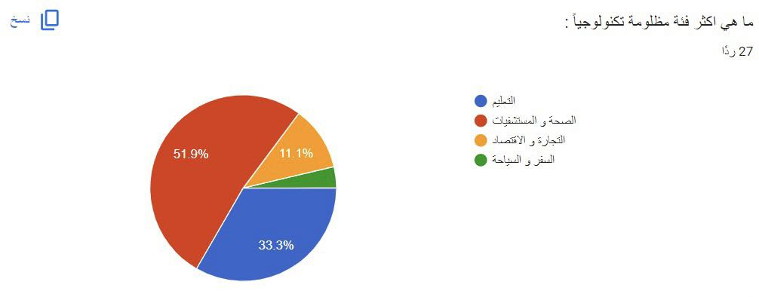

**These are some responses that include medicine:**

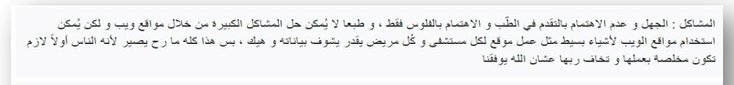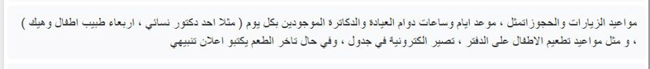

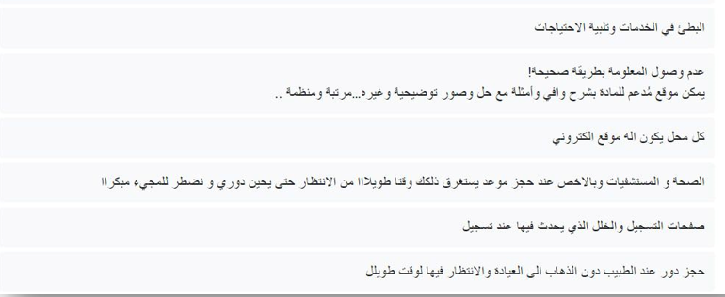

* 1. **Document conventions**

This document uses the following conventions.

|  |  |
| --- | --- |
| ***COC*** | ***Clinic On Call*** |
| **ER** | **Entity Relationship** |

* 1. **Problem statement**

Problems that occur without this system :

* Lost time: Patients can have to wait long times in clinics or call the clinic directly for their appointments, which takes up valuable time.
* Difficulty in communication: It may be difficult to communicate with clinics during official working hours or in emergency situations.
* Increased inconvenience: Appointments may require phone calls and waiting in lines.
* Lack of transparency: There may not be an easy way for patients to access information about the availability of certain appointments or check their current booking status.
  1. **Scope**

All clinics in West Bank.

* 1. **System objectives**

1- Efficient Appointment Scheduling: Enable patients to book medical appointments conveniently and efficiently through an online interface, reducing the need for phone calls or in-person visits to schedule appointments.

2- Time Saving: Save time for both patients and healthcare providers by automating the appointment booking process and reducing wait times.

3- Accessibility: Improve access to healthcare services by providing patients with a user-friendly platform accessible anytime and anywhere with an internet connection.

4- Improved Communication: Facilitate communication between patients and healthcare providers by providing features such as appointment reminders and notifications.

5- Flexibility in scheduling: A patient can schedule, reschedule, or cancel appointments at their convenience.

* 1. **Intended audience**

The system we want to create is designed for use by three types of people: doctors, patients, and clinic staff (such as secretaries and other employees).

- Each **doctor** will have their own account with their specific information (name, ID number, medical specialization, other workplaces besides the clinic, certifications, years of experience, etc.), which will be visible to the patient to help them choose their suitable doctor.

- As for the **patient**, they will have their own private account, accessible only by the doctor and clinic staff (providing security and encryption). Patients will log in using their ID number, and their information (name, ID number, age, medical history, chronic diseases if any, etc.) will be available to the doctor to study the case and understand each patient's complaint.

- **Clinic staff** will be responsible for responding to patients, organizing appointments, and informing them of any developments or clinic-related matters. They will have their own account with their information (name, ID number, job title, services provided at the clinic, etc.), and patients can communicate with the doctor through this staff member and seek necessary consultations.

* 1. **References**

**.** [**https://krazytech.com/projects/sample-software-requirements-specificationsrs-report-airline-database**](https://krazytech.com/projects/sample-software-requirements-specificationsrs-report-airline-database)

**.**[**https://docs.google.com/forms/d/e/1FAIpQLSdJpSxckYHwdrxKT9Sb0n54m33RmDXb_do0uEJVnz6dGUHzKw/viewform?fbclid=IwAR109b7-HeROISVOx7YSh9tZEPiJ_TjinFjN0gbMf25hspprV34fHVoR1P0_aem_AaAK9k6egzftvldqPRkWKdHTxQCmUBeXKAglew-v_Df7opDWOMLWAhJyfXLNNlgzJue7VfHQnCl09xaSTRx6MjUE**](https://docs.google.com/forms/d/e/1FAIpQLSdJpSxckYHwdrxKT9Sb0n54m33RmDXb_do0uEJVnz6dGUHzKw/viewform?fbclid=IwAR109b7-HeROISVOx7YSh9tZEPiJ_TjinFjN0gbMf25hspprV34fHVoR1P0_aem_AaAK9k6egzftvldqPRkWKdHTxQCmUBeXKAglew-v_Df7opDWOMLWAhJyfXLNNlgzJue7VfHQnCl09xaSTRx6MjUE)

**Github links :**

<https://github.com/raghadabuzainih>

<https://github.com/RamaAnbosi>